Transforming a Top 3 Pharmaceutical Company’s Legal Contract Analysis with AutoReports: Saving ≈62,500 Hours a Year
AI is rapidly becoming a strategic asset for major pharmaceutical organizations. For one Top 3 Pharmaceutical Company, in this case study referred to as “The Pharma Company,” analyzing high-value legal documents plays a critical role in staying competitive. Between complex rebate agreements, strict regulatory requirements, and the financial implications of contract terms, The Pharma Company’s need for fast, accurate, and secure insights has never been greater.
Together, Intel and Iternal Technologies have partnered to provide a unique solution that supports one of the Top 3 Pharma Companies via the Turnkey AI platform and its no-code Generative AI document analysis solution, AutoReports, to transform legal contract analysis.
The Pharma Company can now confidently extract key actionable insights like rebate eligibility, rebate revenue potential, contract expiration dates, compliance requirements, and more.

Benchmark Results
Running LLAMA 3.1 70B, an Intel Gaudi Server can process a legal contract that is 16 Pages (3068 Words) in 20.88 seconds generating 478 tokens; or 8 Pages (1534 Words) in 19.05 seconds generating 426 tokens. The ability to process ≈2 million pages of text per month on a single Gaudi 2 core demonstrates the scalability and efficiency of this approach.
Assuming 30 minutes for a lawyer to complete the same 16 page contract review, the AI can save approximately 62,500 hours of effort processing 2 million pages a year.
- Average Response Length in Tokens: 452 tokens
- Response Time per Token: 22.36 - 22.89 tokens per second.
- Pages of legal text per Minute: 45.9 pages
- Number of Contract Queries per Month: 124,137 queries
- Total Legal Contract Pages Processed per Month: 1,986,192 pages
At this capacity and scale, a single Gaudi 8X Server can provide enough capacity to support the entire legal department of The Pharma Company. Saving the company thousands of hours of expensive billable legal hours.

Why GenAI for Contract Analysis Matters & Why You Should Care
Deploying AI to evaluate thousands of pages of contracts, amendments, attachments, exhibits, and compliance documents goes far beyond simple data lookups. It requires extracting quality, accurate, and contextually relevant insights at scale.
- For The Pharma Company’s contract analysts, data preparation and legal document information gathering have traditionally been a time-consuming process.
- In the past, lawyers would have to sift through millions of contracts manually each year (a feat near impossible because of the cost) to identify opportunities for contract rebates, as well as other legal actions such as contract renewals, and updating contract language for compliance upon renewal.
- The highly complex and mentally taxing process of manually reviewing documents makes it hard to quickly identify and categorize contract terms, rebate thresholds, or expiration timelines.
- Additionally, if time runs out, and a contract must either be cancelled or renewed as is, because the window for renegotiation is missed, the contract may have to be renewed with old or outdated terms which could introduce risk and loss to the business.
- With millions of legal contracts under management, the risk exposure can add up to hundreds of millions of dollars.
Leveraging the Turnkey AI platform and AutoReports, The Pharma Company can seamlessly ingest massive volumes of legal text from internal repositories, contract management systems, and even external websites. By using trusted information and a patented indexing approach, AutoReports helps analyze the long and complex legal documents through no-code workflows at millions scale, extract key insights, and makes it easy for legal teams to determine which contracts should be the highest priority to work on based on business value.
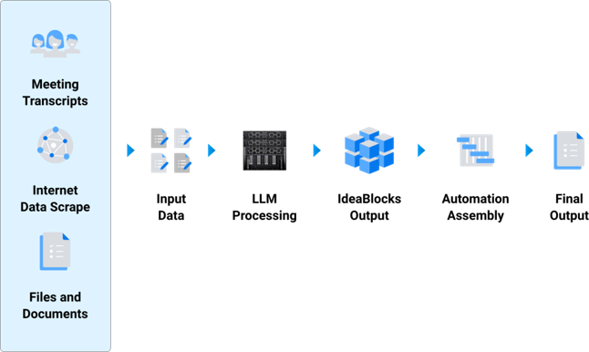

AutoReports In Action: A Summary of the Document Analysis Solution
At its core, AutoReports streamlines unstructured text analysis by enabling users to quickly assemble no-code fully automated LLM workflows. The solution can ingest multiple data sources such as word documents, PDFs, TXT files, emails, and other media formats and then process those documents through a specific user specified workflow, empowering The Pharma Company to extract and highlight critical legal contract details in minutes rather than hours or days.

Ingestion and Optimization with Blockify®
AutoReports uses Iternal’s patented Blockify technology to break documents down into “IdeaBlocks” of verified content. These IdeaBlocks are rich with a robust metadata taxonomy containing information specific to the questions and information needed by the legal team. This not only improves retrieval speed but also practically eliminates AI hallucinations and boosts LLM accuracy—by as much as 78× compared to traditional generative AI pipelines.

AI-Driven Insights with AutoReports
Once documents have been “Blockified,” AutoReports employs large language models to extract and identify key information such as rebate eligibility, rebate revenue estimates, compliance obligations, or approaching contract expiration dates.
Queries using AutoReports are fully configurable and can be deployed as LLM prompts via the Critical Question prompt field contained within each IdeaBlock
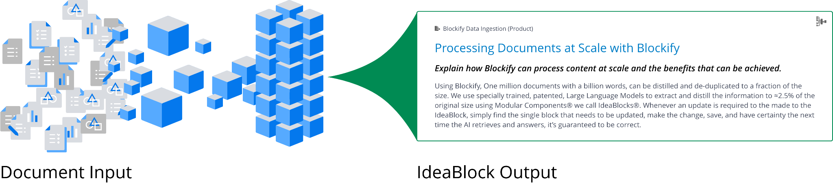
AutoReports makes it easy for users to develop specialized queries using the IdeaBlocks to extract summaries and insights from the documents such as
- What is the threshold and cap for liability and indemnification under this contract?
- What are the Formal Names of Legal Entities party to the contract?
- Does the contract have any rebate terms?
- Are the rebate terms still active / eligible based on any expiration dates?
- What products are eligible for rebate?
- What are the criteria for the rebate terms?
- “Which contracts require compliance auditing in the next quarter?”
Each query can be run in just a few seconds. Because the Turnkey AI platform running on Intel Gaudi supports “Bring Your Own Model” the AutoReports solution can plug and play the latest GenAI LLMs to process information with the highest degree of performance.
Additionally because of how AutoReports processes insights at the IdeaBlock level, different parts of the AutoReport can tap into different LLMs, meaning a document could be processed using 1, 2, 3 or more unique LLMs, whether standard or fine-tuned, for even more specialized processing.

Flexible Deployment of Iternal Turnkey AI with Intel Gaudi
Through the global partnership with Intel, the Turnkey AI platform scales to meet enterprise demands by leveraging the Gaudi platform for inference at scale.
Turnkey AI features a robust API for bulk jobs, paired with Zero Trust security, version control, real-time updates, and compliance. The API makes it easy for customers to quickly integrate AutoReports seamlessly, in just hours, into existing contract management, customer relationship management (CRM), document management, or enterprise resource planning (ERP) systems, ensuring faster lifecycles and better collaboration across teams.

Use Cases for Legal Teams
Some of the easiest solutions for legal teams to deploy at scale quickly to accelerate contracting review and optimization include:
- Contract Term Analysis and Extraction: Automatically identify and extract crucial details—such as payment schedules, termination clauses, or liability limits—from contracts. By quickly surfacing these key elements, businesses streamline compliance efforts and reduce the risk of overlooked obligations.
- Meta-analysis of Reports for Aggregate Insights: Combine data from multiple reports into a single, cohesive overview for deeper understanding. This holistic view reveals trends, patterns, and strategic opportunities that might otherwise remain hidden in individual documents.
- Legal Term and Renewal Updates: Track and update critical legal clauses, ensuring timely awareness of upcoming renewals and revised obligations. Automated alerts and aggregated insights enable proactive decision-making and stronger compliance.
- Contract Negotiation Redlining: Simplify the process of reviewing and revising contract language by automatically flagging proposed edits. This reduces negotiation time, clarifies communication, and helps teams reach mutually beneficial agreements faster.
- Procurement Evaluation and Criteria Eligibility: Assess proposals against standardized procurement requirements, highlighting each vendor’s strengths and weaknesses. This targeted approach speeds up the evaluation process and promotes fair, data-driven selection decisions.
- Risk Mitigation and Risk Exposure Identification: Extract potential risk factors from financial, legal, or operational documents to create a consolidated view of vulnerabilities. By identifying threats early, organizations can strategically address issues and protect their core interests.

Business Use Cases: Real-Time AI Analysis in Action
AutoReports’ adaptability is key for a range of high-impact business scenarios within the pharmaceutical industry:
- Rebate Agreement Management and Revenue Tracking: With AutoReports, rebate administrators rapidly assess evolving payer contracts to confirm compliance with government programs and quickly identify opportunities for improved rebate structures. Summaries highlight contract length, renewal costs, eligible product categories, and potential revenue tied to each rebate clause.
- Expiration and Compliance Alerting: Between new product launches and constantly changing industry regulations, The Pharma Company must ensure its contracts remain up-to-date. AutoReports pinpoints pending deadlines and compliance steps, then automatically notifies teams responsible for renegotiating or updating documentation.
- Mergers and Acquisitions Contract Harmonization: As an organization acquires or partners with new entities, it faces a flood of legacy agreements, each with unique terms, conditions, and compliance requirements. AutoReports consolidates and categorizes these contracts into standardized blocks, accelerating the due diligence process and uncovering critical synergy or risk factors.
- Regulatory Filings and Reporting: Generate regulatory reports detailing how certain contract clauses align with federal, state, or industry-specific mandates. By distilling large contract repositories into bite-sized compliance summary blocks, AutoReports streamlines the review of these lengthy filings.
By automating what was once a heavily manual and often error-prone workflow, organizations can retain a competitive edge in both negotiations and day-to-day contract management.

Conclusion
For a Top 3 Pharmaceutical Company operating in a tightly regulated environment, harnessing AI for contract analysis is a game-changer. With AutoReports as a core component in the Turnkey AI platform, powered by Intel Gaudi, key provisions like rebate eligibility, compliance obligations, or contract expiration dates are no longer hidden in dense legal text. Instead, critical insights are revealed in seconds, enhancing decision-making and driving immediate value for legal, finance, and compliance teams.

