Transforming a Global Manufacturing Giant: Accelerating Supply Chain and Procurement through an AI-Enabled Workforce
AI has become a critical competitive differentiator for global manufacturers. For one Fortune 200 Manufacturing Company, in this case study referred to as “The Manufacturing Company,” managing high-volume supplier contracts and materials agreements, supply chain resource allocation, and revenue generating rebates is highly complex. The Manufacturing Company’s business units operate in an environment where accurate, fast, and secure data analysis isn’t just nice to have, it’s essential.
Traditional solutions require an unaffordable amount of man power and are often siloed, slow to adapt, and limited in actionable insights. Iternal Technologies, in partnership with Intel’s advanced Gaudi AI infrastructure, is delivering a comprehensive solution that enables manufacturing organizations to scale through the power of Generative AI.
From optimizing the supply chain and procurement pipelines to empowering employees with AI-driven decision-making, Iternal’s Turnkey AI platform, featuring AutoReports, Nebulous™, Blockify®, and AirgapAI™, is redefining the way manufacturing giants can work smarter and faster at scale.

Benchmark Results
Running LLAMA 3.1 70B on an Intel Gaudi Server, AutoReports can process a 12-page (3,003-word) supplier or vendor agreement in just under 15.85 seconds (generating 426 tokens), or a 9-page document (2,406 words) in about 15.48 seconds (399 tokens). At near real-time speeds, a single Gaudi 2 core can process roughly 2 million pages of text per month.
In a manual workflow, contract specialists may spend upwards of 22.5 minutes reviewing a typical 12-page agreement. Replacing some of those steps with AI yields a savings of around 62,500 hours annually when scaling to 2 million pages. The impact on speed, throughput, and cost is game-changing for The Manufacturing Company’s global teams, who juggle thousands of active contracts at any given moment.
- Average Response Length in Tokens: ≈412.5
- Response Time per Token: 26.33 tokens/second
- Pages of Legal or Technical Text per Minute: ≈45.96
- Typical Contract Queries per Month: ≈166,000
- Total Contract Pages Processed per Month: ≈1,985,472
At this capacity, a single Gaudi 8X server can support the entire legal and procurement departments of The Manufacturing Company, saving countless hours of high-value staff time and reducing risk exposure in global operations.

The Business Value for GenAI for Supply Chain Contract Analysis
Contracting in a global manufacturing giant like The Manufacturing Company is highly complex, spanning everything from raw materials sourcing to equipment leasing, logistics, warranties, and regulatory compliance. A single business unit handles countless agreements, attachments, exhibits, and compliance documents each year.
- Manual Effort: Historically, teams would sift through these contracts on a case-by-case basis, an extremely time-consuming process.
- Missed Opportunities: Important clauses - like volume discounts, compliance deadlines, or renegotiation windows - could be overlooked, leading to additional costs or inefficiencies. They also require manual input into ERP systems.
- Risk Exposure: Renewing contracts “as is” because a renegotiation window was missed can lock the company into outdated terms, which can add up to significant risk and increased cost over time.
By automating document ingestion, classification, and summarization, AutoReports gives The Manufacturing Company’s contract analysts a powerful new capability to identify, categorize, and act on critical contract details instantly.

Iternal’s Turnkey AI In Action
Iternal’s Turnkey AI platform offers a suite of solutions that span use cases across every department of an organization.

Ingestion and Optimization with Blockify®
Iternal’s patented Blockify technology to ingests and distills information from documents into “IdeaBlocks,” pieces of verified content enriched with metadata taxonomies that match The Manufacturing Company’s sales, marketing, education, supply chain, legal, and compliance needs. This approach dramatically reduces inaccurate AI inferences (hallucinations) by as much as 78X (7,800%) versus traditional text-parsing pipelines. Guaranteed structured data indexing means employees trust the AI’s recommendations - critical for high-stakes negotiations or technical validations.
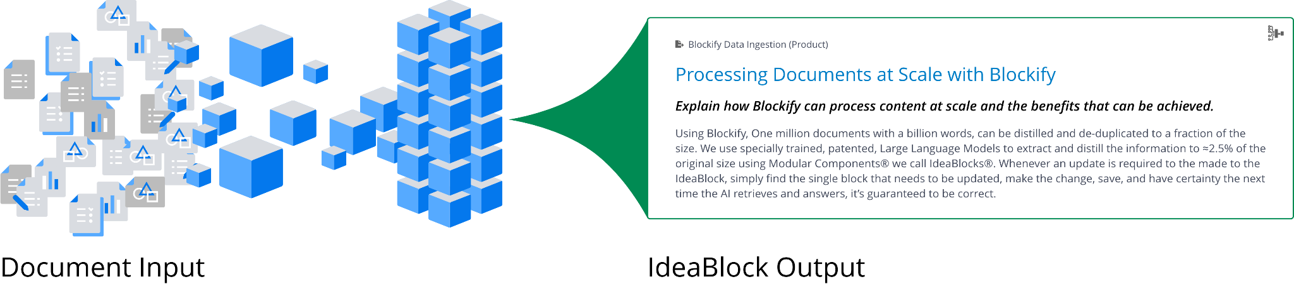
Blockify also enables consistent & Trusted Insights by eliminating duplicated or conflict-prone text, reducing confusion and ensures a single source of truth; perfect for merging large catalogs of engineering specs, compliance mandates, or supplier contracts.

AI-Driven Insights with AutoReports
AutoReports empowers non-technical users to interact with a no-code interface that ingests and processes contracts at massive scale - Word docs, PDFs, TXT files, or emails. Within minutes, The Manufacturing Company’s teams can highlight the critical terms and obligations that matter the most.
Imagine a busy contract specialist buried under a stack of 16-page supplier agreements - a task that used to take over 30 minutes per document. With AutoReports™, that same dense contract is ingested and transformed into an actionable summary in under 21 seconds.
Across millions of pages, what once consumed countless hours now happens almost instantly. AutoReports™ doesn’t simply digitize documents; it understands them.
By automatically parsing key terms such as payment schedules, rebate opportunities, penalty clauses, and renegotiation windows, it empowers teams to shift from reactive paperwork skirmishes to proactive business strategy sessions.
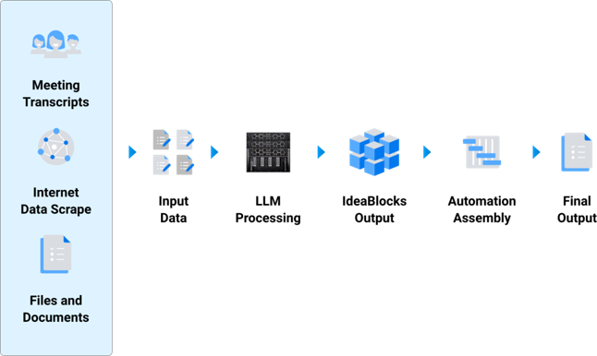
Once all documents are “Blockified,” large language models identify specific requests defined by the users such as warranty terms, performance metrics, or product codes. Specialized prompts can quickly reveal:
- Payment due dates or penalty schedules under a supplier agreement
- Whether a contract includes price-break clauses for large volumes
- Potential performance or compliance audits required in the next quarter
- Which contracts allow for renegotiation or mid-term amendments
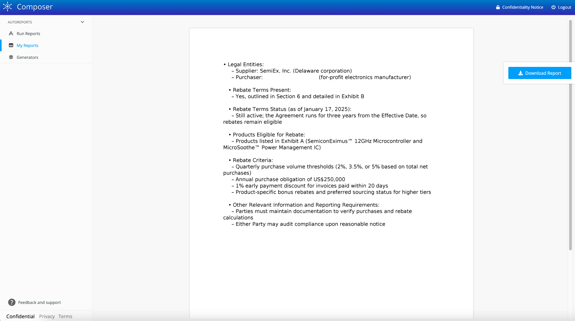
With Turnkey AI’s “Bring Your Own Model” approach on Intel Gaudi, The Manufacturing Company can integrate the latest GenAI LLMs and fine-tune them for even more specialized use cases in different global markets.
AutoReports can also be used for:
- RFP/RFI Vendor Submission Review
  - Vendor evaluation and selection from an RFI or RFP process
  - Ideal for quickly sizing up vendor proposals, identifying hidden cost efficiencies, or ensuring compliance with global regulations.
- Bulk Contract Analysis
  - Automate the ingestion of legal documents, procurement proposals, or engineering specifications.
  - Extract only the key elements - prices, terms, compliance requirements - turning thousands of pages into an actionable summary in minutes.
- Enhanced Decision Speed & Accuracy
  - Move from days or weeks of manual review to near real-time insights.
  - Significantly reduce reliance on costly, error-prone manual analysis and let teams focus on higher-value tasks such as strategy and relationships.

Nebulous™: Outcome-Driven Prioritization
In a sprawling enterprise where critical tasks pressure every moment of the day, keeping teams focused on high-value tasks is a constant challenge.
Nebulous™, an first of its kind, outcome-driven prioritization engine that brings clarity to complexity. By dynamically ranking tasks based on robust, real-time metrics, Nebulous™ ensures that the most urgent and impactful activities - whether it’s alerting teams about upcoming contract renewals or flagging potential supply chain disruptions - always rise to the top. 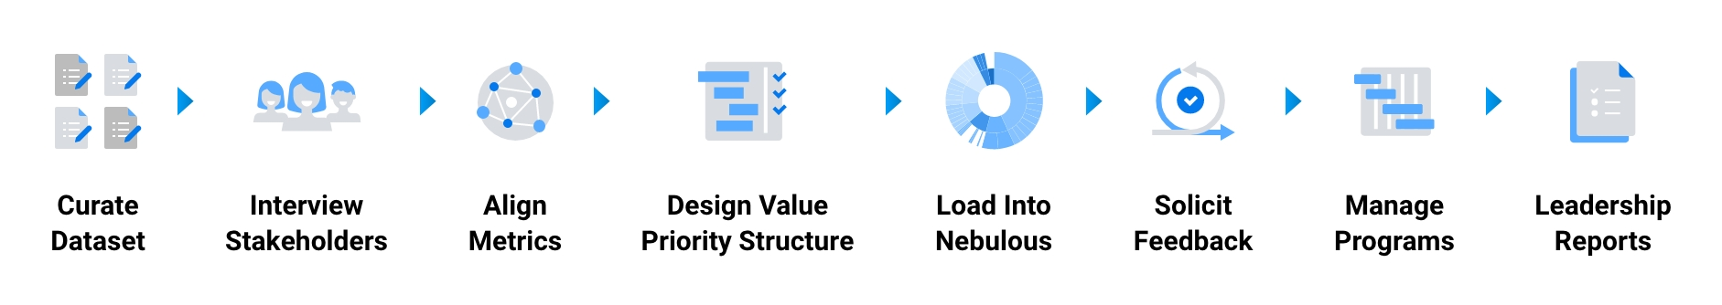
In a global organization, even a minor shift in priority can ripple across multiple departments, and Nebulous™ makes sure that those ripples translate into focused, strategic action without the guesswork typical of traditional management.
Powered by Intel Gaudi for LLM analysis, Nebulous enables task ingestion to become automated, allowing users to quickly align tasks and priorities and find “diamond in the rough” opportunities for optimal ROI.
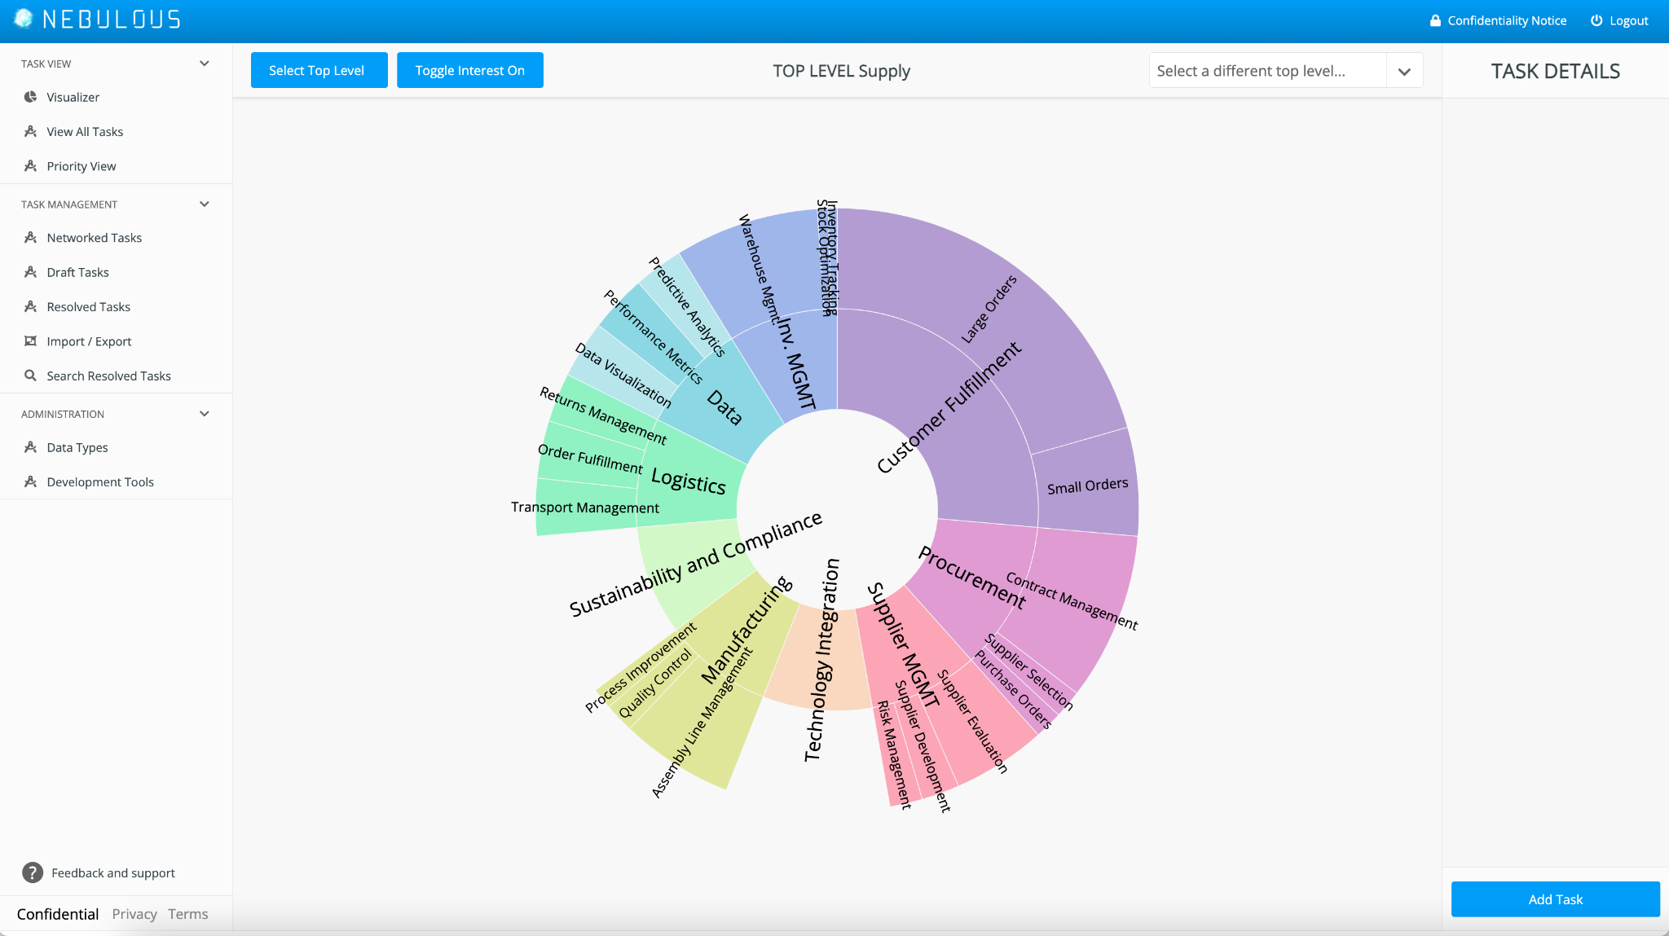
- Real-Time Resource Allocation
  - 63% faster time to respond to mission critical actions
  - 230% improved employee efficiency on completing tasks on skill level
  - 68X improved prioritization accuracy through metrics backed decision making
  - Dynamically prioritize the most critical supply chain or procurement tasks based on potential impact, ensuring that high-value activities (e.g., large orders, urgent shipments) never slip through the cracks.
  - Simple “top-level” reallocation updates ripple through your global dashboards, guaranteeing everyone is aligned on the same priorities.
- Objective, Unbiased Ordering of Work
  - Minimize politics and guesswork that often plague enterprise prioritization.
  - Base decisions on robust, quantifiable metrics, enabling fast pivots when market conditions, raw material availability, or leadership directives change.

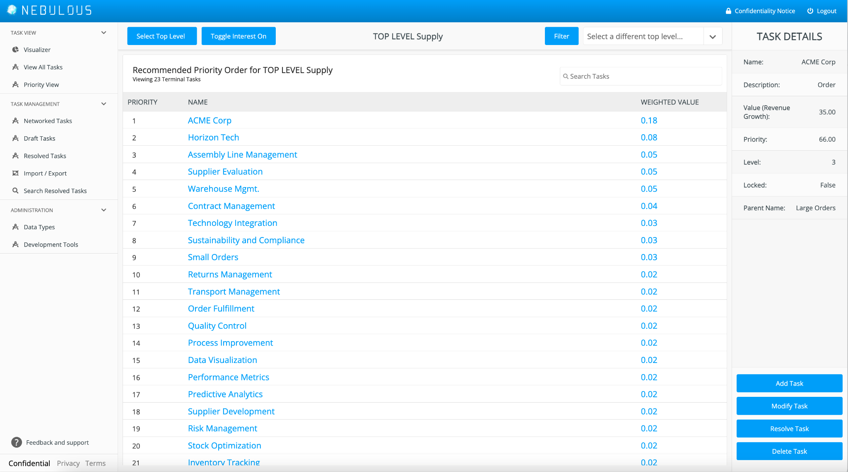

AirgapAI™: Offline, Secure AI for the Workforce
For The Manufacturing Company, security isn’t negotiable. With sensitive manufacturing details, proprietary supplier information, and critical compliance documents at stake, data sovereignty is paramount.
AirgapAI™ answers this need by running entirely offline on secure Intel NPUs. There’s no reliance on external networks - only fast, reliable, localized processing that guards against breaches and ensures compliance with the strictest regulatory standards.
This offline capability is complemented by role-based AI personas that serve different functions, whether for procurement, engineering, or legal, each drawing on curated data sets tailored to their specific needs.
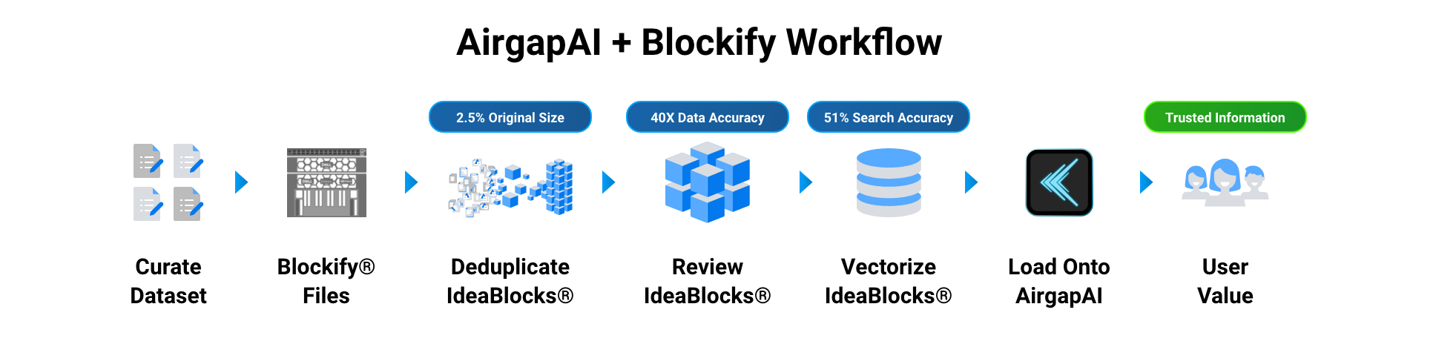

- Local Execution, Zero Network Required
  - For sensitive manufacturing details, intellectual property, or regulated data, AirgapAI offers complete offline operation on a secure Intel NPU.
  - Retain total data sovereignty and remove external dependencies - ideal for remote sites or when network reliability is low.
- Curated AI Personas & Workflows
  - AirgapAI supports Bring Your Own Model allowing you to run any smaller Open Source LLM directly on the device - including fine-tuned versions.
  - Assign specialized AI “personas” for maintenance, design, procurement, or sales. Each persona draws from specific data sets, ensuring top-notch relevance.
  - Role-based guardrails enforce data governance, letting each department harness AI safely within pre-approved content.

Flexible Deployment of Turnkey AI with Intel Gaudi
Iternal’s Turnkey AI platform is enterprise-ready, featuring:
- Bulk API for High-Volume Jobs: Quickly process entire libraries of contracts.
- Zero Trust Security and Role-Based Access: Protect sensitive supply chain and legal data.
- Real-Time Updates and Version Control: Ensure every stakeholder always works with the most current contract terms.
Within hours, The Manufacturing Company’s digital transformation teams can leverage AutoReports and integrate directly into existing systems like ERP platforms, contract management tools, or vendor management databases, without disrupting ongoing operations.

AutoReports Procurement & Legal Use Cases
Use cases abound for the Turnkey AI platform in the procurement, legal, and supply chain spaces to include:
- Contract Term Extraction & Compliance: Automatically highlight key terms or compliance clauses (like import/export regulations, local labor requirements, or .gov certifications).
- Renewal & Revisions Tracking: Provide proactive alerts on expiring agreements, ensuring that renegotiation opportunities or updated compliance obligations aren’t missed.
- Material Supply & Pricing Analysis: Match negotiated unit prices or volume discounts across multiple suppliers to ensure The Manufacturing Company capitalizes on the best deals.
- Risk Mitigation & Liability Checks: Identify risk factors, like indemnification or liability caps, to protect The Manufacturing Company from potential legal or financial exposure.
- Global Supplier Contract Management: AutoReports quickly delineates shipping terms, stock availability, and penalty clauses for thousands of vendor contracts - compressing the lead time for supply chain decision-making.
- Manufacturing Equipment Leases & Service Agreements: Summaries of equipment lease timelines, possible extension options, or service-level agreements (SLAs) help engineering and operations teams plan maintenance schedules.
- Mergers & Acquisitions Due Diligence: In acquisitions, The Manufacturing Company can rapidly parse a newly acquired company’s contracts and assess synergy or risk factors - speeding up integration timelines and clarifying compliance obligations.
- Regulatory Filings & Internal Audits: Generate compliance reports detailing how supply chain contracts align with local or international trade regulations.

Supply Chain Synchronization
- Demand & Inventory Alignment: Use Nebulous to rank alternative suppliers or shipping routes based on real-time data. High-priority items (e.g., critical components with short lead times) receive immediate attention.
- AutoReports for Vendor Assessments: Instantly analyze vendor performance records, shipping terms, and regulatory compliance. Identify cost-savings in parallel with securing reliable delivery schedules.
- AirgapAI & On-Site Decision Support: Remote or on-the-go supply chain managers can run full-scope document processing from an AI-enabled laptop with no need for a stable internet connection.

Procurement & Contract Management
- Large-Scale RFP Processing: AutoReports extracts must-have specs and compliance terms from each proposal, drastically reducing time from RFP submission to final awarding. Uncover “hidden gem” vendor deals or conflicting clauses that can be renegotiated.
- Nebulous-Enhanced Prioritization: Assign each procurement project a priority percentage. A massive multi-million dollar supply deal might rank higher than smaller, routine purchases - ensuring the right project gets the best talent assigned first.
- Blockify-Verified Insights: Contract language is chunked and verified so procurement teams trust that automatically extracted data (like payment schedules) is accurate before final sign-off.

AI-Driven Employee Enablement
- Accelerated Onboarding: New hires or cross-functional teams can query AirgapAI to quickly ramp up on past projects, product specs, or corporate policies. By tapping into curated knowledge derived from Blockify, employees avoid the noise of outdated or conflicting docs.
- Role-Based Workflows: Deploy custom AI personas through AirgapAI. An engineering persona could handle engineering documentation Q&A, a procurement persona for analyzing cost breakdowns, and a compliance persona for addressing safety regulations.
- Faster Innovation Cycles: Freed from time-consuming program management and dependency mapping, employees can put more effort toward predictive analytics, design improvements, or green initiatives. Nebulous ensures cross-department alignment, making sure every new drive for innovation fits the highest business-value opportunities.
With massive volumes of data digitized and “Blockified,” it’s possible to extract, collate, and act upon crucial insights that once stayed buried in PDFs or Word documents.

Bringing It All Together
By uniting these capabilities, The Manufacturing Company is poised to accelerate its transformation - lowering operating costs, fueling innovation, and keeping the global manufacturing pipeline running smoothly, even in the face of unexpected disruptions.
Iternal’s Turnkey AI platform - powered by Intel Gaudi accelerators - provides a hyper-efficient framework that modernizes how The Manufacturing Company tackles supply chain strains, procurement processes, and employee enablement:
- AutoReports for lightning-fast high-volume document understanding.
- Nebulous for outcome-driven prioritization so teams focus on what truly moves the needle.
- Blockify for maximizing AI accuracy and trust across massive unstructured data troves.
- AirgapAI for secure, offline AI experiences and consistent, LLM role-based knowledge workflows anywhere on the globe.
This agility translates directly to improved negotiation leverage, fewer supply chain disruptions, and reduced risk. By automating once-manual, error-prone processes, The Manufacturing Company can reassign valuable staff time toward more impactful initiatives, such as innovation, expansion, or sustainability projects.
When every minute counts - especially in a volatile global market - Turnkey AI provides the rapid, reliable, and secure insights The Manufacturing Company needs to keep operations ahead of the curve.

